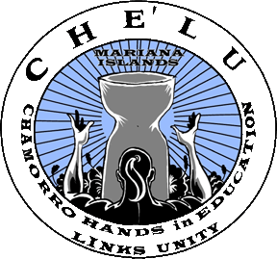
Chamorro Cultural Fest 2015
Booth Registration Form

Name of Business or Organization:
Applicant's Name:
Address:
City: State: Zip Code:
Phone: Fax: Email:
State Franchise Tax Number: Resale Number:

If you are a non-profit organization, attach a copy of your certificate and provide your organization's nonprofit IRS 501(c)(3) number:

Point of contact at the event?:
Contact Phone:
Number of spaces requested:
Select booth type: Food $300 (___) Retail/Non-Food $250 (___) Information/Resource $100 (___)

Specific description of booth and products to be sold:

Food vendors must list all items sold and have the proper health permit(s) issued from the County of San Diego Department of Health Services.
(Electrical outlets are not generally available at this event.)

CHE’LU assumes no responsibility for any loss, damage, injury, or claims arising out of participant’s acts or omissions during the Chamorro Cultural Festival at CSU-San Marcos. Alcohol and consumption of alcohol is prohibited outside of designated area at this event.

I have read, understand, and agree to all venue rules as provided in the 2015 Vendor Rules document. I also understand that my space rental fee is non-refundable after March 7, 2015.

Print Name:
Signature: Date:

CHE’LU Representative: Date:

Mail Form to:
CHE’LU, C/O June Hawkins, P.O. Box 742126, San Diego, CA 92174-2126

